Grading Test 4th Kyu
Name of Student:__________________________________________
Date: __________________________________________

Punches: | Yama Zuki  Awase Zuki  Heiko Zuki  Haishu Uchi
Kicks: | Mikazuki Geri  Gyaku Mawashi Geri
Blocks: | Haishu Uke  Tenagashi Uke  Tae Osae Uke  High and Low Posture  Antenna Posture
Kata: | Kensei Godan  Heian Godan
Kumite: | Ippon: 14,15  Sunbon: 10,11,12
Self Defence: | Lapel Holds
Past Syllabus-Mandatory | All Past Syllabus will be tested randomly, Kumites included.
Tameswari  ( Breaking Technique): | 1/4" x 4 (Together) with Seiken Zuki
Examiner:___________________________________________
Total Marks: ________________________________
© Copyright 1998 Karate Do Kenseikan Canada

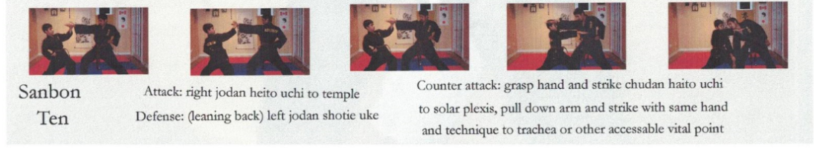
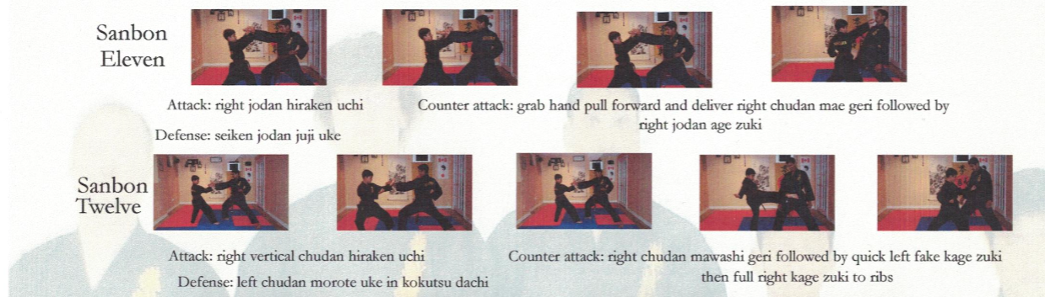
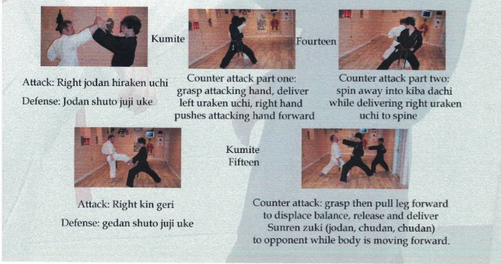

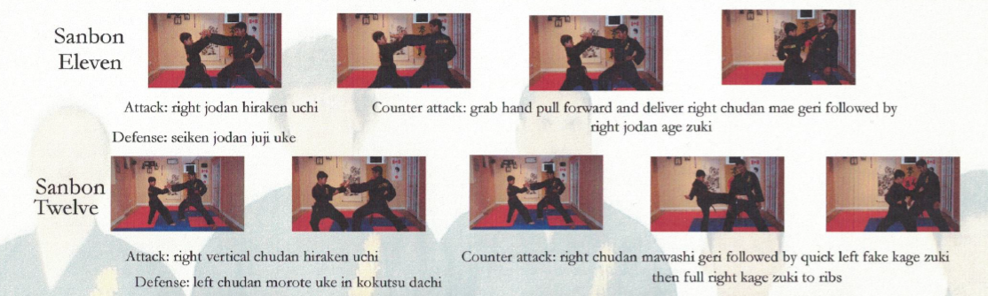
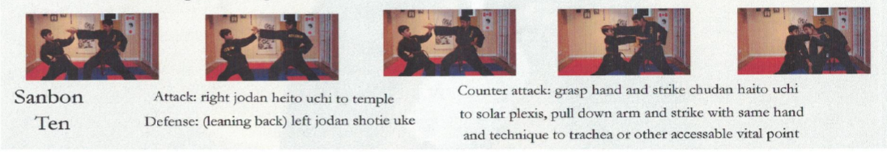
right chudan mawashi geri followed by right tate zuki in zenkutsu dachi

